Group By

Note: Display the party code, not the party description in each of the following
1) Display the number of people in each party. Order by Party. (Make sure to display the party_code)
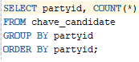

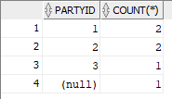
2) Display the number of people in each party whose first name starts with d or r. (Make sure to display the party_code)
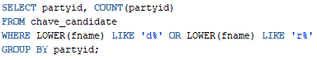

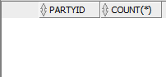
3) Display the average salary for each party (Make sure to display the party_code)
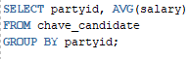

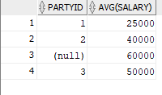

4) Display the number of people in each party where the number of people does not exceed 2
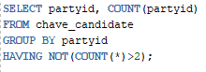
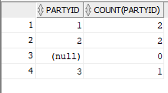
5) Display the average salary for each party where the average does not exceed 50000
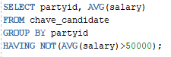

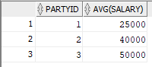
6) Create a new table called candidate2 that contains the number of people in each party. Should contain the partycode and the number of people (CAUTION, you have to use an alias for this to work)
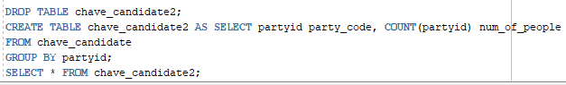

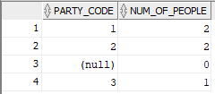

Eliminating nulls
